Joel Edwards
Course: Java Programming 1
Homework 3
April 9, 2011

1)

Source:

ParseEval.java:
import java.util.ArrayList;
import java.util.StringTokenizer;

class ParseEval
{
public static final int NONE = 0;
public static final int ADD = 1;
public static final int SUBTRACT = 2;

private static void error(String message) {
System.out.println("E: " + message);
System.exit(1);
}

public static void main(String[] args) {
StringTokenizer tokenizer;
ArrayList<String> tokens = new ArrayList<String>(args.length);

// Look for tokens within each token returned from the command-line
for (String arg: args) {
tokenizer = new StringTokenizer(arg, "-+", true);
while (tokenizer.hasMoreTokens()) {
tokens.add(tokenizer.nextToken());
}
}

boolean last_was_value = false;
int last_delimiter = ADD;
double value = 0;
double total = 0;
int token_index = 1;
for (String token: tokens) {
if ("+".compareTo(token) == 0) {
if (!last_was_value) {
error("Adjacent operators are not allowed");
}
last_delimiter = ADD;
last_was_value = false;
} else if ("-".compareTo(token) == 0) {
if (!last_was_value) {
error("Adjacent operators are not allowed");
}
last_delimiter = SUBTRACT;
last_was_value = false;
} else {
try {
value = Double.parseDouble(token);
if (last_was_value) {
error("Adjacent values are not allowed");
}
last_was_value = true;
if (last_delimiter == SUBTRACT) {
total -= value;
} else if (last_delimiter == ADD) {
total += value;
} else {
// This should never occur
error("Unsupported arithmetic operation");
}
} catch (NumberFormatException e) {
error("Unsupported input value '" +token+ "'");
}
}
token_index++;
}

System.out.println("" + total);
}
}

Output:
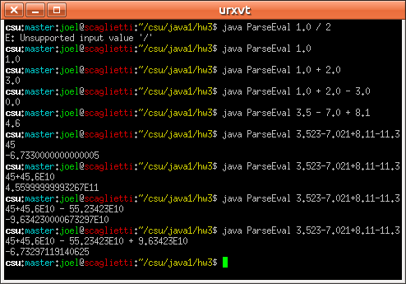

2)

Source:

DrawT.html:
<html>
<head>
<title>A Simple Program</title>
<meta http-equiv="pragma" content="no-cache" />
</head>
<body>
Here is the output of my program:
<applet code="DrawTApplet.class" width="300" height="400">
</applet>
</body>
</html>

DrawTApplet.java:
import java.applet.Applet;
import java.awt.Color;
import java.awt.Graphics;

public class DrawTApplet
extends Applet
{
private static final int NEG = -1;
private static final int POS = 1;

private Graphics g = null;

public void paint(Graphics g) {
this.g = g;
this.resize(300, 400);
this.setBackground(Color.white);

// Draw line segments
this.drawPyramid(Color.RED, 1, 50, POS, 50, POS, 249, NEG, 50, POS);
this.drawPyramid(Color.GREEN, 1, 249, NEG, 50, POS, 249, NEG, 99, NEG);
this.drawPyramid(Color.ORANGE, 1, 249, NEG, 99, NEG, 174, NEG, 99, NEG);
this.drawPyramid(Color.BLUE, 1, 174, NEG, 99, NEG, 174, NEG, 349, NEG);
this.drawPyramid(Color.YELLOW, 1, 174, NEG, 349, NEG, 125, POS, 349, NEG);
this.drawPyramid(Color.MAGENTA, 1, 125, POS, 349, NEG, 125, POS, 99, NEG);
this.drawPyramid(Color.DARK_GRAY, 1, 125, POS, 99, NEG, 50, POS, 99, NEG);
this.drawPyramid(Color.PINK, 1, 50, POS, 99, NEG, 50, POS, 50, POS);
}

public void drawLine(Color c, int x1, int y1, int x2, int y2) {
this.g.setColor(c);
this.g.drawLine(x1, y1, x2, y2);
}

public void drawPyramid(Color c, int depth,
int x1, int dx1,
int y1, int dy1,
int x2, int dx2,
int y2, int dy2) {
for (int i = 0; i < depth; i++) {
this.drawLine(c,
x1 + (dx1 * i),
y1 + (dy1 * i),
x2 + (dx2 * i),
y2 + (dy2 * i));
}
}
}

Output:

Single pixel lines were a little too thin, so I created the drawPyramid method in order to draw the T with line thickness determined by the depth parameter. The results were pretty interesting for a depth of 25 (second screenshot).

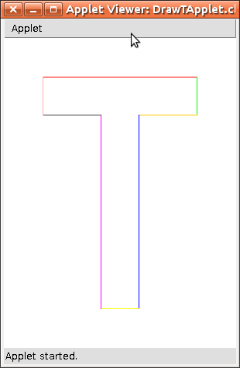
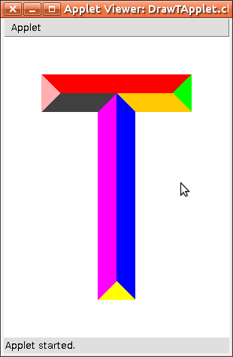

3)
String's split method(s) can quickly breaking up a String into an array of tokens based on more complex delimiters than those allowed by StringTokenizer. This would be useful for parsing a log file.

4)
Graphics' clearRect method is useful for clearing portions of the Graphics' canvas, or the entire canvas. This proved useful in the following problem (5).

5)

Source:

DrawTResize.html:
<html>
<head>
<title>A Simple Program</title>
<meta http-equiv="pragma" content="no-cache" />
</head>
<body>
Here is the output of my program:
<applet code="DrawTResizeApplet.class" width="300" height="400">
</applet>
</body>
</html>

DrawTResizeApplet.java:
import java.applet.Applet;
import java.awt.Color;
import java.awt.Container;
import java.awt.event.ComponentListener;
import java.awt.event.ComponentEvent;
import java.awt.Graphics;

public class DrawTResizeApplet
extends Applet
{
private Graphics g = null;
private int w_div = 6; // Divide width by this value to determine width of stemp of the T
private int h_div = 8; // Divide height by this value to determine height of cross of the T

public void paint(Graphics g) {
this.g = g;

this.setBackground(Color.WHITE);
this.g.setColor(Color.BLACK);

// Here we handle the re-sizing of the Applet, and ignore all other
// events returned by the ComponentListener
this.addComponentListener( new ComponentListener() {
public void componentHidden(ComponentEvent e) { ; }
public void componentMoved(ComponentEvent e) { ; }
public void componentResized(ComponentEvent e) {
DrawTResizeApplet a = (DrawTResizeApplet)e.getComponent();
a.redrawT();
}
public void componentShown(ComponentEvent e) { ; }
});

this.redrawT(); // Draw the initial T prior to any resize events
}

public void redrawT() {
int width = this.getWidth();
int height = this.getHeight();

// We use these ratios to determine whether the T's dimension should
// be calculated with respect to width or height.
double targetRatio = (float)(this.w_div) / (float)(this.h_div);
double dimRatio = (float)(width) / (float)(height);

int top_x; // x-coordinate of upper left corner of the T's cross
int top_y; // y-coordinate of upper left corner of the T's cross
int top_w; // width of T's cross
int top_h; // height (thickness) of T's cross
int cnt_x; // x-coordinate of the upper left corner of the T's stem
int cnt_y; // y-coordinate of the upper left corner of the T's stem
int cnt_w; // width (thickness) of the T's stem
int cnt_h; // height of the T's stem

// Calculate dimensions with respect to height
if (dimRatio > targetRatio) {
top_y = height / h_div;
top_y = (top_y < 1) ? 1 : top_y;
top_h = top_y;
top_h = (top_h < 1) ? 1 : top_h;
cnt_y = top_y;
cnt_y = (cnt_y < 1) ? 1 : cnt_y;
cnt_h = height - ((top_y) * 2);
cnt_h = (cnt_h < 1) ? 1 : cnt_h;

cnt_w = top_h;
cnt_w = (cnt_w < 1) ? 1 : cnt_w;
cnt_x = width / 2 - (cnt_w / 2);
cnt_x = (cnt_x < 1) ? 1 : cnt_x;
top_w = cnt_h * w_div / h_div;
top_w = (top_w < 1) ? 1 : top_w;
top_x = width / 2 - (top_w / 2);
top_x = (top_x < 1) ? 1 : top_x;
}
// Calculate dimensions with respect to width
else {
top_x = width / w_div;
top_x = (top_x < 1) ? 1 : top_x;
top_w = width - ((top_x) * 2);
top_w = (top_w < 1) ? 1 : top_w;
cnt_x = (width / 2) - ((top_x) / 2);
cnt_x = (cnt_x < 1) ? 1 : cnt_x;
cnt_w = top_x;
cnt_w = (cnt_w < 1) ? 1 : cnt_w;

cnt_h = top_w * h_div / w_div;
cnt_h = (cnt_h < 1) ? 1 : cnt_h;
cnt_y = height / 2 - (cnt_h / 2);
cnt_y = (cnt_y < 1) ? 1 : cnt_y;
top_h = cnt_w;
top_h = (top_h < 1) ? 1 : top_h;
top_y = cnt_y;
top_y = (top_y < 1) ? 1 : top_y;
}

this.g.clearRect(0, 0, width, height); // Remove previous T image
this.g.fillRect(top_x, top_y, top_w, top_h); // Draw T's cross
this.g.fillRect(cnt_x, cnt_y, cnt_w, cnt_h); // Draw T's stem
}
}

Output:
